# Laboratory 7

**State chart diagrams**

1. **Introduction and Purpose of Experiment**

Students will apply object oriented analysis and design for the given scenario for low level design of classes

1. **Aim and Objectives**

**Aim** To develop low level software design for a given class diagram using state chart diagrams

**Objectives:** At the end of this lab, the student will be able to

* + Identify states of each object
  + Identify triggers and messages for each object
  + Understand the behavior of a class, given its state chart diagram

1. **Experimental Procedure**

* Work in teams of 4 students
* Each team should read the class diagram and identify objects, interactions and states of objects
* Each team will then design state transitions and simulate the same. They will then document the design in an low level design specification document
* Each individual will then write their lab manual, documenting their observations

1. **Presentation of Results**

State Chart Diagram:

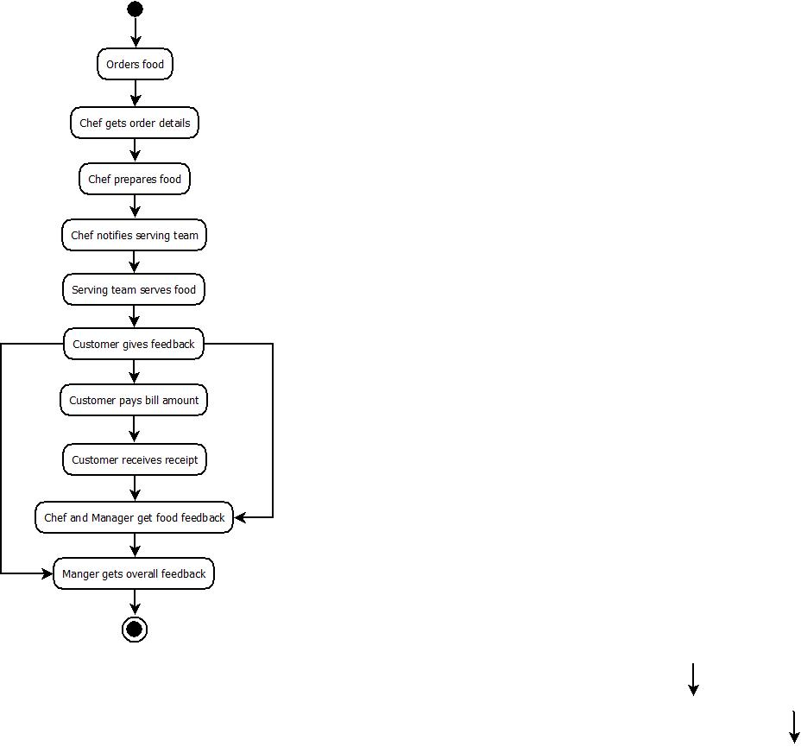

1. **Analysis and Discussions**
2. **Conclusions**
3. **Comments**

**1. Limitations of Experiments**

**2. Limitations of Results**

**3. Learning happened**

**4. Recommendations**

|  |  |  |
| --- | --- | --- |
| **Component** | **Max Marks** | **Marks Obtained** |
| **Viva** | **6** |  |
| **Results** | **7** |  |
| **Documentation** | **7** |  |
| **Total** | **20** |  |